Amadeusz Deutry

File System Documentation

**OVERVIEW**

A filesystem provides an operating system with the ability to read, write, and modify files on secondary storage devices. The responsibilities of an effective file system include the proper management of files and directories and minimizing the possibility of corrupt or damaged data. A file system should also provide the operating system with and user with a convenient and reliable interface which is able to perform operations on the directories and files already on the filesystem.

**DESIGN**

For my implementation of a filesystem I chose to follow the design of the FAT32 filesystem. The file system itself is stored in one file on a real machine. This file is separated into 3 parts: the boot sector, the FAT table, and the data section. (Traditional FAT filesystem implementations include two FAT tables for consistency but only one is included in this implementation.)

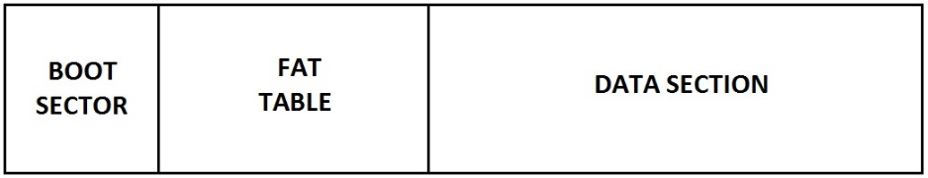

***Fig 1.*** *Overview of the filesystem structure*

The boot sector contains the size of the filesystem, the starting offset of the FAT table, the FAT table entry size, the starting offset of the data section and the data section cluster size. This is not included in traditional FAT system implementations but for this particular implementation it allows for various filesystem sizes.

**THE FAT TABLE AND FILE ALLOCATION**

The disk on which the filesystem resides is divided into equally sized portions called clusters. The FAT table is a list of entries each of which map into a cluster which resides on the physical disk. In this implementation the physical disk is separated into clusters of 512 bytes and the FAT table entries are 4 bytes each. Of course files can be bigger than the space provided by a single cluster. Therefore clusters can be chained together into a linked list allowing files to make use of several clusters. This is achieved by including a pointer to the next cluster within each FAT entry. Every file has an associated beginning FAT entry which maps into the very first cluster that the file occupies. When the file system needs to retrieve the file it first reads all the data from the first cluster and then uses the pointer inside the FAT entry to locate the next cluster. A special marker is set to specify that a given cluster is the last cluster of the file. The first entry in the FAT table is reserved for the root directory which resides in the data section.

**THE DATA SECTION AND PHYSICAL ALLOCATION**

The data section includes the actual file data including the directory tables. As mentioned before the data section is divided into 512 byte clusters. The data section includes directory tables which are special files that describe the contents of a filesystem directory. A directory table includes entries for each item in the directory. Each entry is 32 bytes in size and includes information such as whether the item is a file or a directory, a pointer to the first FAT cluster of the item, the file name, and dates of creation and last modification. Entries can specify whether the item is a directory or a file. This allows for directories to contains subdirectories.

The two diagrams below describes a simple directory file structure and its representation in the FAT table and data sector. Each box represents a directory with the children drawn underneath, connected to the parent. In this diagram the root directory contains two text files and a directory named A. The A directory contains another text file and its own subdirectory named B which happens to be empty.

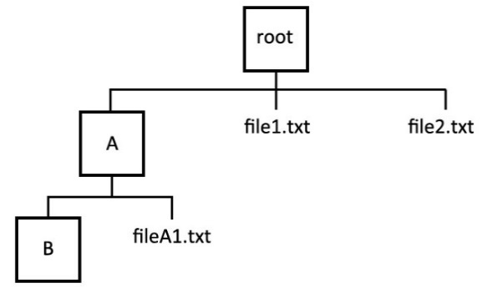

***Fig 2.*** *An example directory structure*

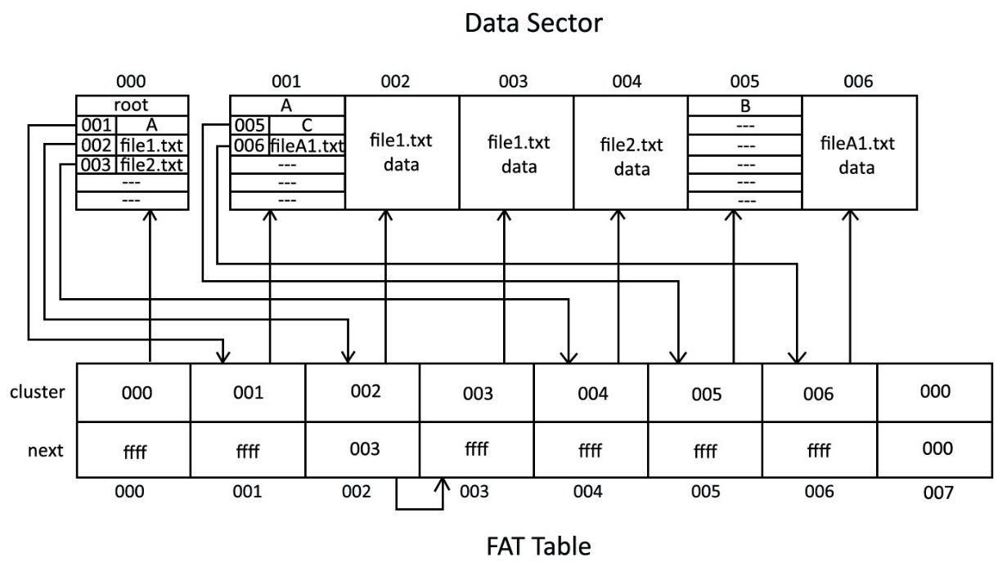

***Fig 3.*** *The example directory structure as stored in the FAT table and data sector.*

The first entry in the FAT table is reserved for the root directory therefore it also points to the first cluster in the data sector. The root directory table contains an entry for each of the directory’s three items. In the diagram we can see that each entry contains the cluster number of the item’s first cluster in the FAT table and the item’s name. In the actual implementation this directory table entry contains additional information including the item type ( file or directory ), the date and time of creation and last modification and the file size. The cluster number maps into a FAT table entry which is shown as the bottom table in Fig 3.

A FAT entry includes the cluster number of the next cluster in the file chain and a pointer to the cluster which this FAT entry maps to. The purpose of including a data field which specified the next cluster in the file chain is to give the filesystem the ability to store files which can occupy multiple clusters. For example the file file1.txt contained in the root directory cannot fit into a single cluster and requires the space of two clusters. We can see that this file’s first FAT entry contains a next value of 003 which points to the FAT entry of the next cluster. The next value of this FAT entry is “ffff” which specifies that this is the last cluster in the cluster chain. From the example can see than every allocated file or directory besides file1.txt can be stored inside a single cluster because the value of “next” is “ffff” for each one.

A filesystem must of course be able to differentiate between files and directories when traversing its directory structure. An important detail to note is that the directory tables allow the filesystem to differentiate between files and directories by storing a value in each directory table entry which specifies the entry as being either a file or directory. Therefore the way that the filesystem treats each data cluster depends on the context which is provided by the data table entries.

Running through an example of a simple file retrieval can provide us with a better understanding of how the filesystem structure operates. Let us suppose that the file system receives the command to open the file located at “/A/fileA1.txt”. We can assume that every file or directory path will be given as an absolute path (relative to the root directory). The first step that the filesystem must perform is locate entry ‘A’ in the in the root directory. The filesystem reads the very first FAT entry in the FAT table which contains a mapping into the first cluster of the root directory. After reading the first cluster it checks the ‘next’ value of the FAT entry to see if the root directory occupies any more clusters. If it does not it passes the data it retrieved from the cluster into a function that handles directory table data. The function parses the directory table data and retrieves the information about each entry including the name and type of the entry. Because we requested to open a file inside the ‘A’ entry of the root directory we must make sure that the ‘A’ entry exists and that it is also a directory. If either of these are false we return the appropriate error. After we have validated that the ‘A’ entry exists and is indeed a directory we can use the entry’s FAT pointer number to locate the first FAT entry of the directory. In this example the first FAT entry of directory A is located at cluster number 001. We can retrieve the FAT entry of this directory by taking the starting index of the FAT table and adding to it the cluster number of the entry times the size of each FAT entry. By looking at FAT entry 001 we can see that directory ‘A’ occupies only one cluster because the next value of its first cluster is ‘ffff’. We load the cluster data and treat it as a directory table just as we did with the root directory and extract the directory information. Our next step is to make sure the file named ‘fileA1.txt’ exists inside the directory and if it doesn’t we throw an error. If the file does exist we navigate to its first FAT entry given by the cluster number in the directory table entry and begin to retrieve the data continuing to navigate to the next cluster in the chain until the final chain has been reached. In this case, however, the file ‘fileA1.txt’ occupies only a single cluster so we do not need to navigate to any other FAT entry.

**IMPLEMENTATION**

The filesystem is stored on a single file which contains the boot sector, FAT table, and data section. This data must first be written to a file filesystem initialization procedure called fs_init. The fs_init function takes as arguments a system file pointer,a boot sector size, a FAT entry size, the desired FAT table length, the size of data clusters and the size of the data section. All of the specified sizes are given in bytes. The function assumes that the file was opened in binary mode instead of text mode. The function creates a data struct which will contain all of these values and writes this struct to the beginning of the filesystem file. The function must also initialize the root directory. Directories in this implementation include one small struct which stores the amount of items in the directory,

|  |
| --- |
| int fs_init(FILE * fs_file,  unsigned int boot_sec_size ,  unsigned int fat_entry_size ,  unsigned int fat_table_size,  unsigned int cluster_size,  unsigned int data_sec_size){  /create a boot sector struct  struct boot_sec init_boot_sec;  //assign values to the struct  init_boot_sec.boot_sec_size = boot_sec_size;  init_boot_sec.fs_size = boot_sec_size + fat_table_size + data_sec_size;  init_boot_sec.fat_table_size = fat_table_size;  init_boot_sec.cluste_size = cluster_size;  init_boot_sec.data_sec_size = data_sec_size;  init_boot_sec.root_start = boot_sec_size + fat_table_size + 1;      //point the filesystem file pointer to the beginning of the file  fseek(fs_file , 0 , SEEK_SET);  //write the struct to the filesystem file  Fwrite(init_boot_sec)  //initialize the directory struct  Struct directory root;  Root.item_count = 0;    //write the directory struct in the index following the fat_table  Fseek(fs_file , boot_sec_size + fat_table_size + 1 , SEEK_SET);    } |

Now when we wish to make use of the filesystem the filesystem will have to read the boot sector struct from the beginning of the file in order to retrieve the indexes of the fat table and root directory.

|  |
| --- |
| Struct boot_sec fs_info;  Fread(fs_info , sizeof(boot_sec) , fs_file) |

The fs_info struct can now be used to retrieve the various filesystem information.

**OPEN FILE**

Open_file takes an absolute path name as a parameter and returns a file system file descriptor. The file system descriptor is a wrapper around the operating system file descriptor which is used by the file system to properly retrieve data from clusters. The function returns NULL if the file does not exist.

|  |
| --- |
| File_descriptor open_file(char* path)  {  Char** args = parse_path(path)  Struct directory cur_dir;  Struct dir_table_entry cur_entry;  //we start at the root directory  Cur_dir = get_root_dir  Entries = get_dir_entries(cur_dir)  I = 0    For each arg in args:  For each entry in entries:  If entry == args[i]  if I == length(path)  Struct file_descriptor fd;  Fd.root_cluster = entry.cluster  return fd  else  cur_dir = entry  break  i++  return null;  } |

**CREATING FILES**

Creating a file involves retrieving the file descriptor for the directory in which we wish to create the file, adding a directory table entry for the file, and allocating the necessary amount of FAT entries and data clusters to fit the file. Create_file takes in the path of the desired file as an argument which includes the name of the file and its extension at the end.

|  |
| --- |
| File_descriptor create_file(String path)  {  //retrieve the file descriptor for the directory where we are creating  //the file  File_descriptor Fd = open_file(path)    //retrieve the directory struct  Directory* dir get_directory(fd)    //allocate space for the directory table entry  dir_table_entry* entry = malloc(32)  //populate the entry  //get_free_block returns the next unallocated FAT entry  entry->fat_index = get_free_block()    //filename includes extension  entry->name=(filename)  entry->size = 0;  //a type of 1 denotes a file as opposed to a directory  entry-> type = 1;  //write the directory table entry into the next available file entry  write_file(entry , fd , index of next free file entry, 32)  return;    } |

**CREATING DIRECTORIES**

|  |
| --- |
|  |

**CLOSING FILES**

|  |
| --- |
|  |

**WRITING FILES**

Writing files involves using the write_file function which takes as parameters a buffer from which data will be read, a file descriptor for the file we wish to write to, the index of the position where we wish to write to, and the amount of bytes to be written into the file. The function has to take into account the fact that the file might be divided into several linked clusters. Therefore it must keep track of where the index is in a particular cluster.

|  |
| --- |
| void write_file(void* buffer, file_descriptor fs, int index, int bytes)  {  Cluster = fs.root_cluster    } |

**READING FILES**

|  |
| --- |
| Void read_file(void* buffer, file_descriptor fs, int index, int bytes)  {  Struct fat_entry cur_fat;  Struct dir_table_entry entry;  //read the directory table entry from the given file descriptor  Fread(entry , root_start + fs.root_cluster*sizeof(dir_table_entry))  //retrieve the first FAT sector from the directory table entry  Fread(cur_fat, boot_sec_size + entry.fat_index*sizeof(fat_entry))  //navigate through the file chain until you’ve reached the index  While(index > 512)  Entry = *(entry.next)  Index -= 512  //read bytes number of bytes from the appropriate sector  Fread(buffer ,root_start + entry.cluster*sizeof(cluster) + index, bytes)    } |

**DELETING FILES**

|  |
| --- |
|  |

**FUNCTIONS**

|  |
| --- |
| //the boot sector struct  struct boot_sec{  unsigned int boot_sec_size:16;  unsigned int fs_size:32;  unsigned int fat_table_size:32;  unsigned int fat_entry_size:8;  unsigned int cluster_size:8;  unsigned int data_sec_size: 32;  unsigned int root_start: 32;    };  Struct fat_entry {  Unsigned int cluster:16;  Unsigned int next:16;  Unsigned int allocated:1;  }  Struct directory {  Unsigned int fat_index:8;  Unsigned int item_count:8;  }  Struct dir_table_entry {  Unsigned int fat_index:8;  Unsigned int name:12;  Unsigned int size:16;  Unsigned int type: 1;  }  Struct file_descriptor {  //the cluster where the file resides  Unsigned int root_cluster:16;  //the entry number of the file inside the directory  Unsigned int entry_no:16;  }  Struct Dir_table_entry* get_dir_entries(directory dir)  {  Ret = malloc(dir.item_count)  For each entry in dir:  Struct Dir_table_entry temp = entry  Ret[i] = entry  Return ret    }  //translates a file descriptor into a directory struct  Directory* get_directory(struct file_descriptor fd)  {  Directory* dir;  //read the directory data into the buffer buff  read_file(dir,fd,32);  return dir  }  Directory get_root_dir()  {  Struct directory temp = malloc  Fread(temp , root_start , fs_file)  Return temp  }  //TODO  Directory open_dir(String dir_path)  {  Struct directory ret = malloc  Struct file_descriptor fd = open_file(dir_path)  Fseek(fs_file, ,SEEK_SET)  Fread(  } |